Project Title: Pharmacy Management System

I. Reasons for choosing the project:
Information technology has been asserting its major role and position in all socio-economic fields. In which information management is a necessary application and brings many benefits.
Currently, retail pharmacies often manage their drugs using books, which takes a lof of time and effort and is not very effective. Therefore, applying information technology and computers to assist in drug management in pharmacies is very necessary.
II. system description:
1. Warehouse department
- warehouse inventory

- import goods
2. Management department
- make an invoice
- payment with customers
- Create a purchase order
- payment with supplier

III. Executive Summary:
The Pharmacy Management System project is a comprehensive software solution designed to facilitate the efficient management and operation of a drug store or pharmacy. The system aims to streamline various aspects of pharmacy management, including inventory control, sales tracking, prescription management, and customer interactions. This report provides an overview of the project's objectives, scope, and key features.

IV.Project Objectives:
1. Inventory Management: Implement a robust system for tracking medication inventory, including real-time updates on stock levels, expiration dates, and restocking alerts.
2. Sales Tracking: Develop a sales module that allows the recording and monitoring of medication sales, generating reports, and insights into product performance.
3. Prescription Management: Create a module for managing prescription records, enabling pharmacists to easily retrieve and process prescriptions.
4. Customer Interactions: Implement customer management functionalities, including customer profiles, loyalty programs, and communication channels for improved customer service.

V. Scope of Work:
The Pharmacy Management System will include the following key features:
1. User Authentication: Secure login system for administrators, pharmacists, and staff members.
2. Inventory Management: A user-friendly interface for tracking medication stock, setting reordering thresholds, and generating purchase orders.
3. Sales and Invoicing: Recording and managing sales transactions, generating invoices, and tracking revenue.
4. Prescription Processing: Managing prescription records, medication dispensing, and ensuring compliance with relevant regulations.
5. Customer Database: Storing customer information, tracking purchase history, and implementing a loyalty program.

6. Reporting: Generating reports on sales, inventory, and customer data for data-driven decision-making.
VI. System menu architecture
- Functional interface
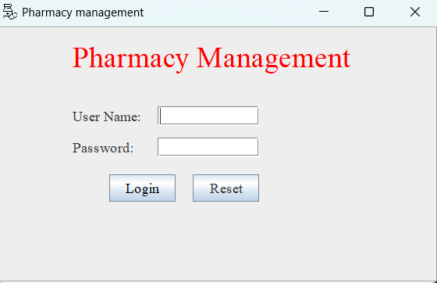
When running the software, the login form will appear. To access, users will have to log in.
When successfully logged in, the main interface of the software will appear.
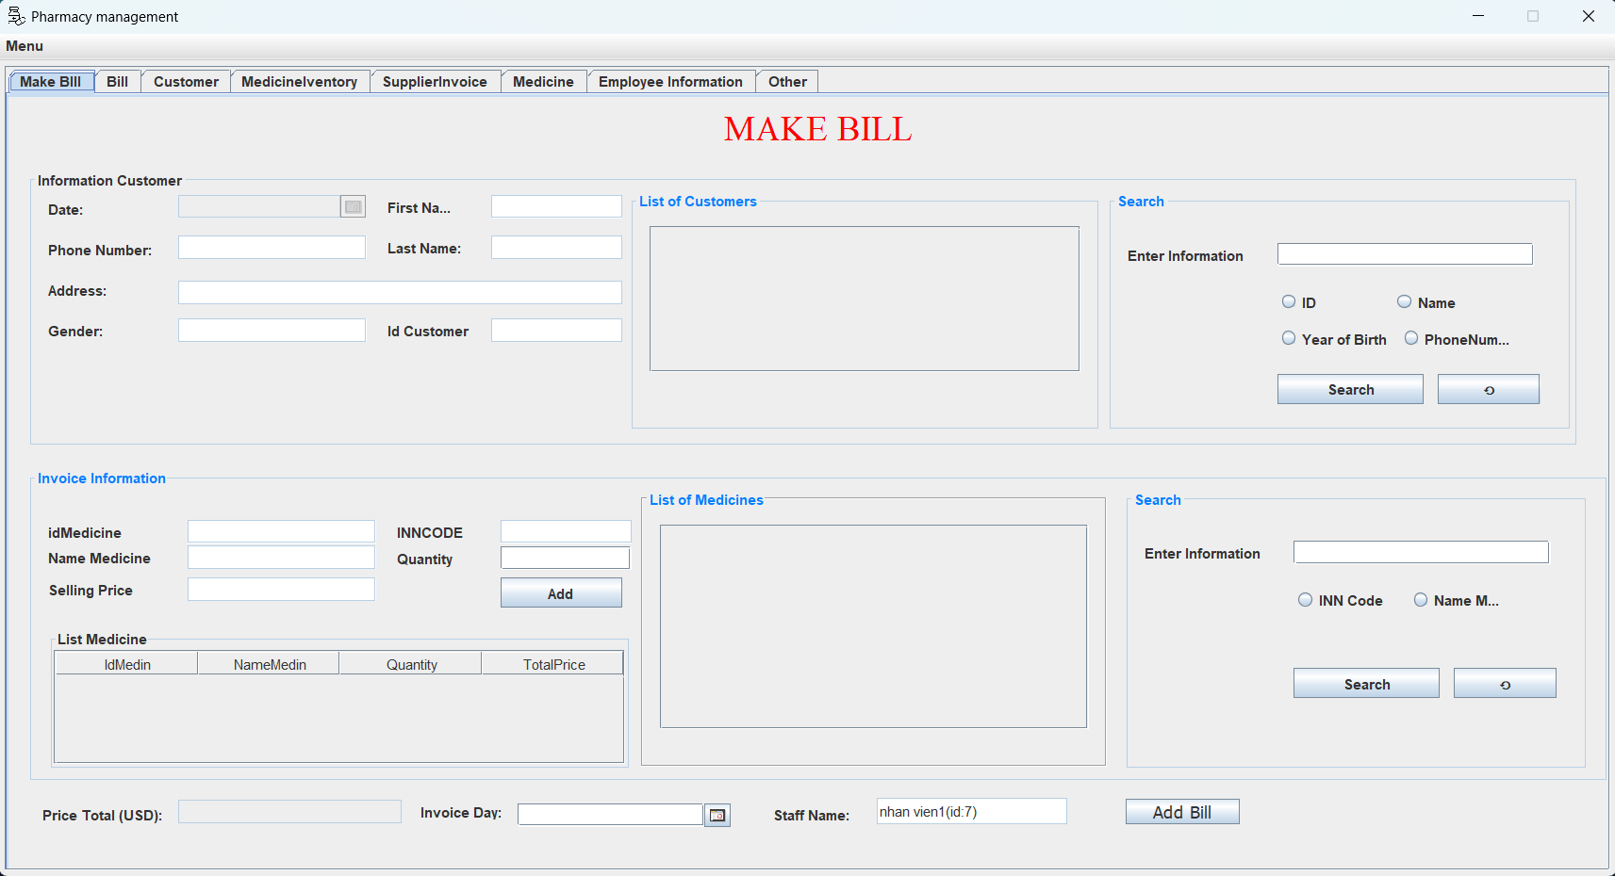

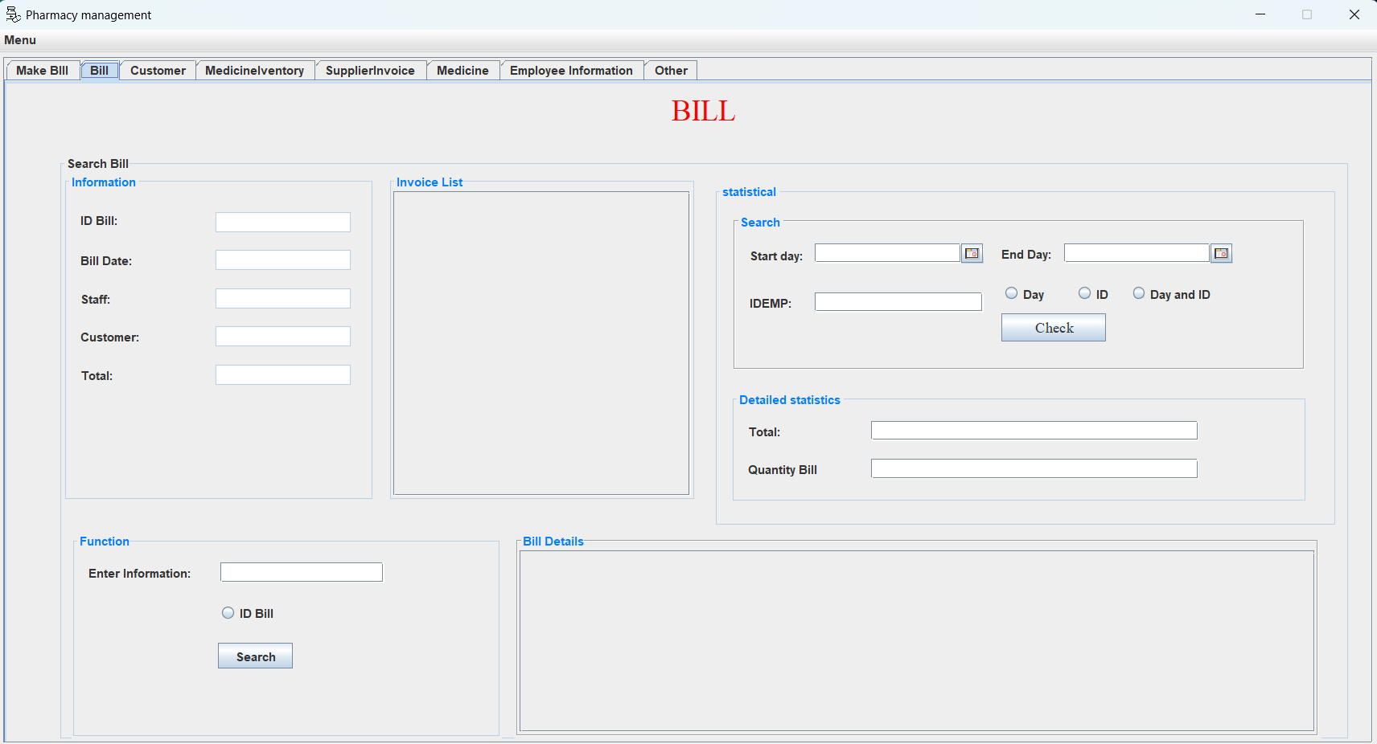
The software has will functions Make bill, bill, customer, medicine warehouse, medicine, employe information, other.

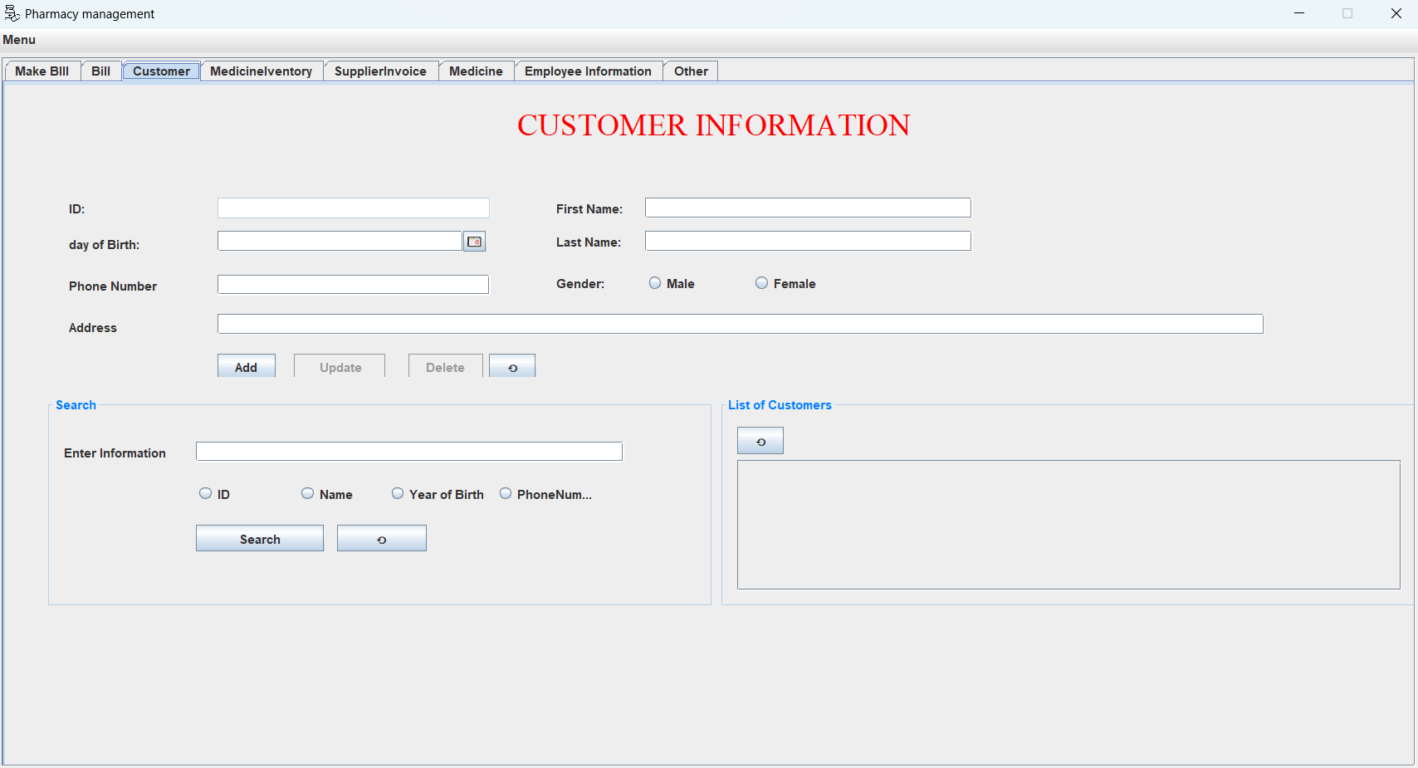

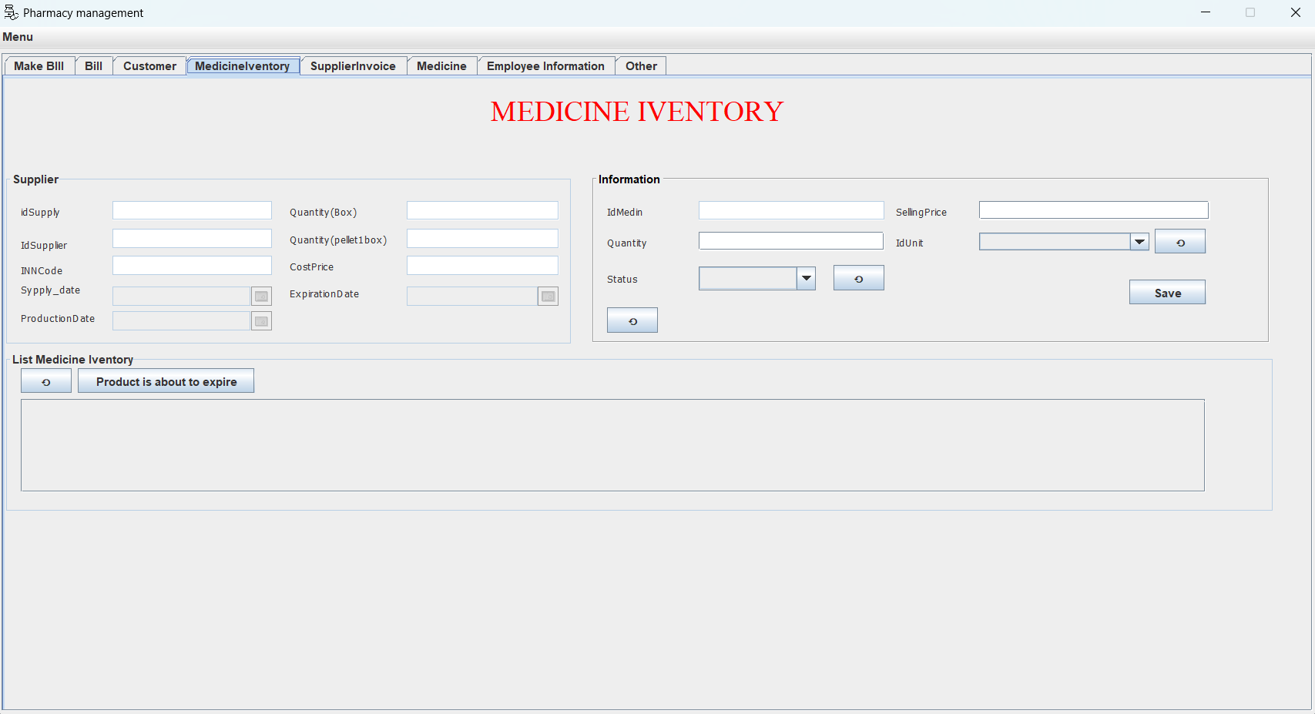

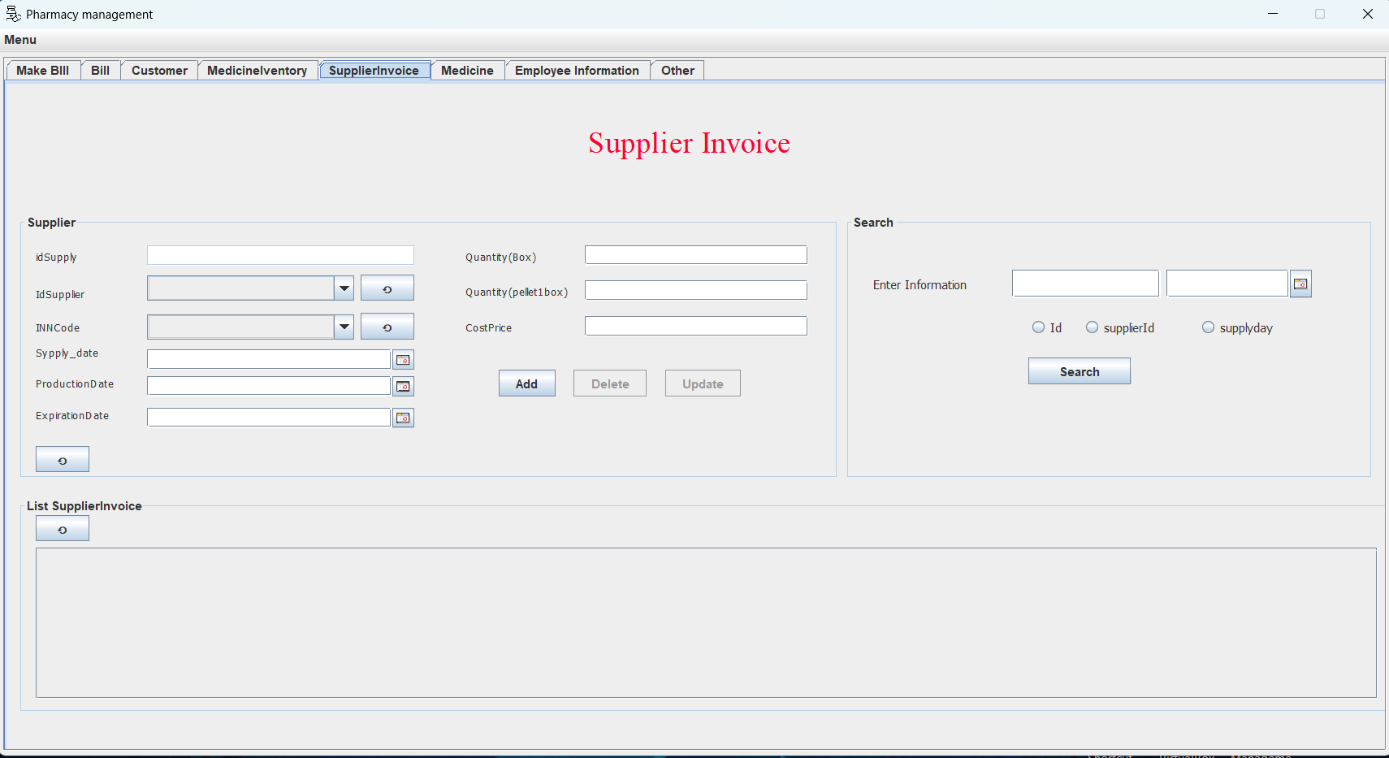
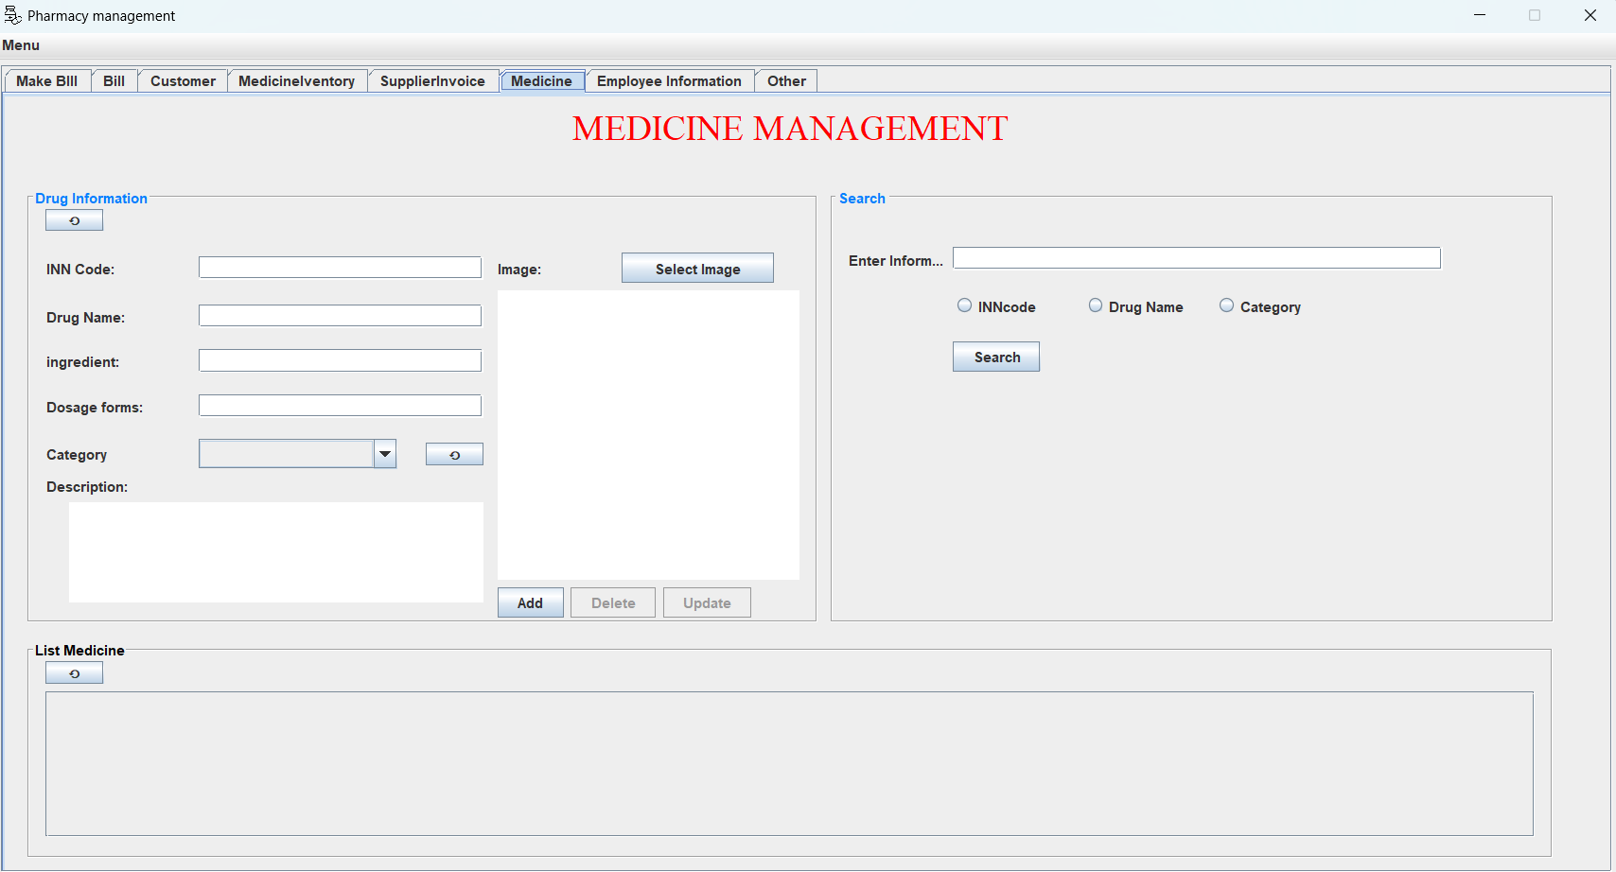
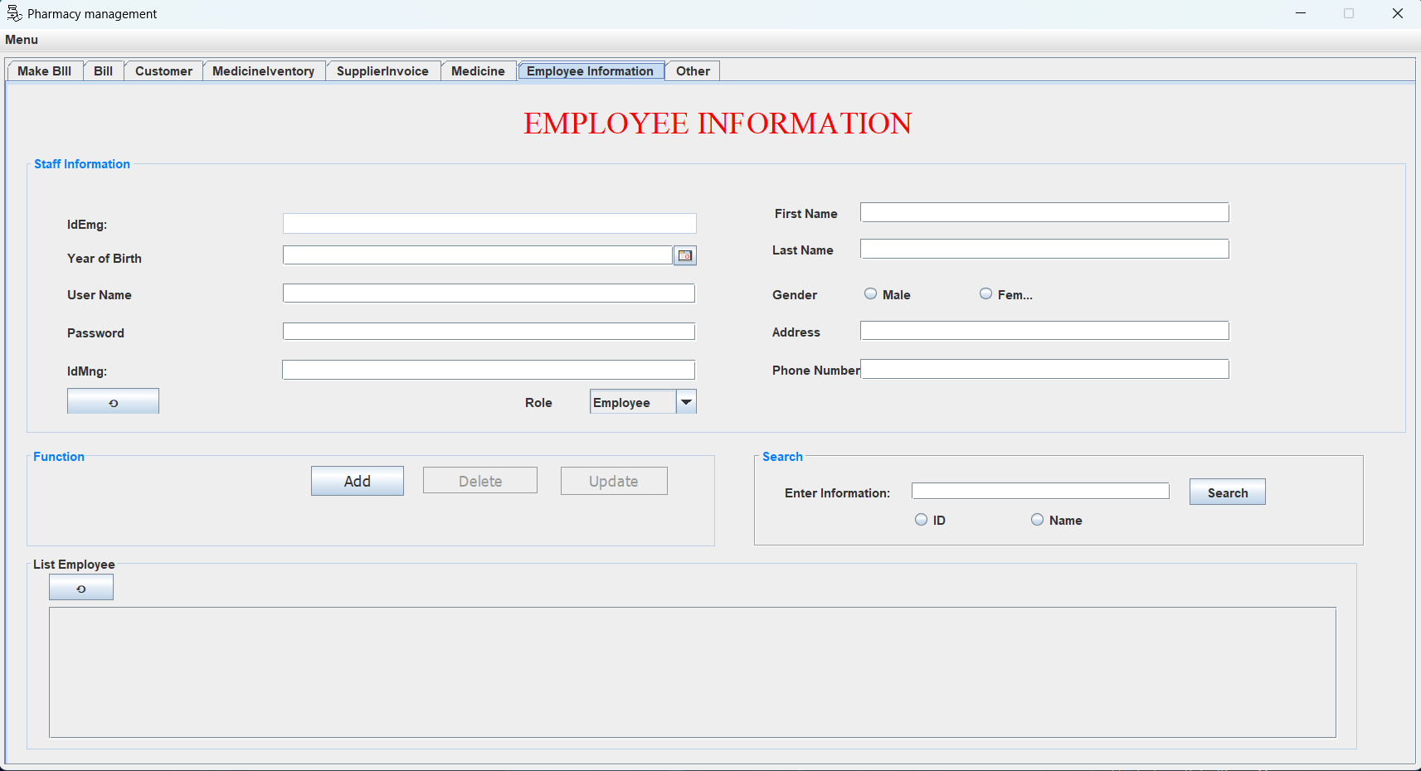
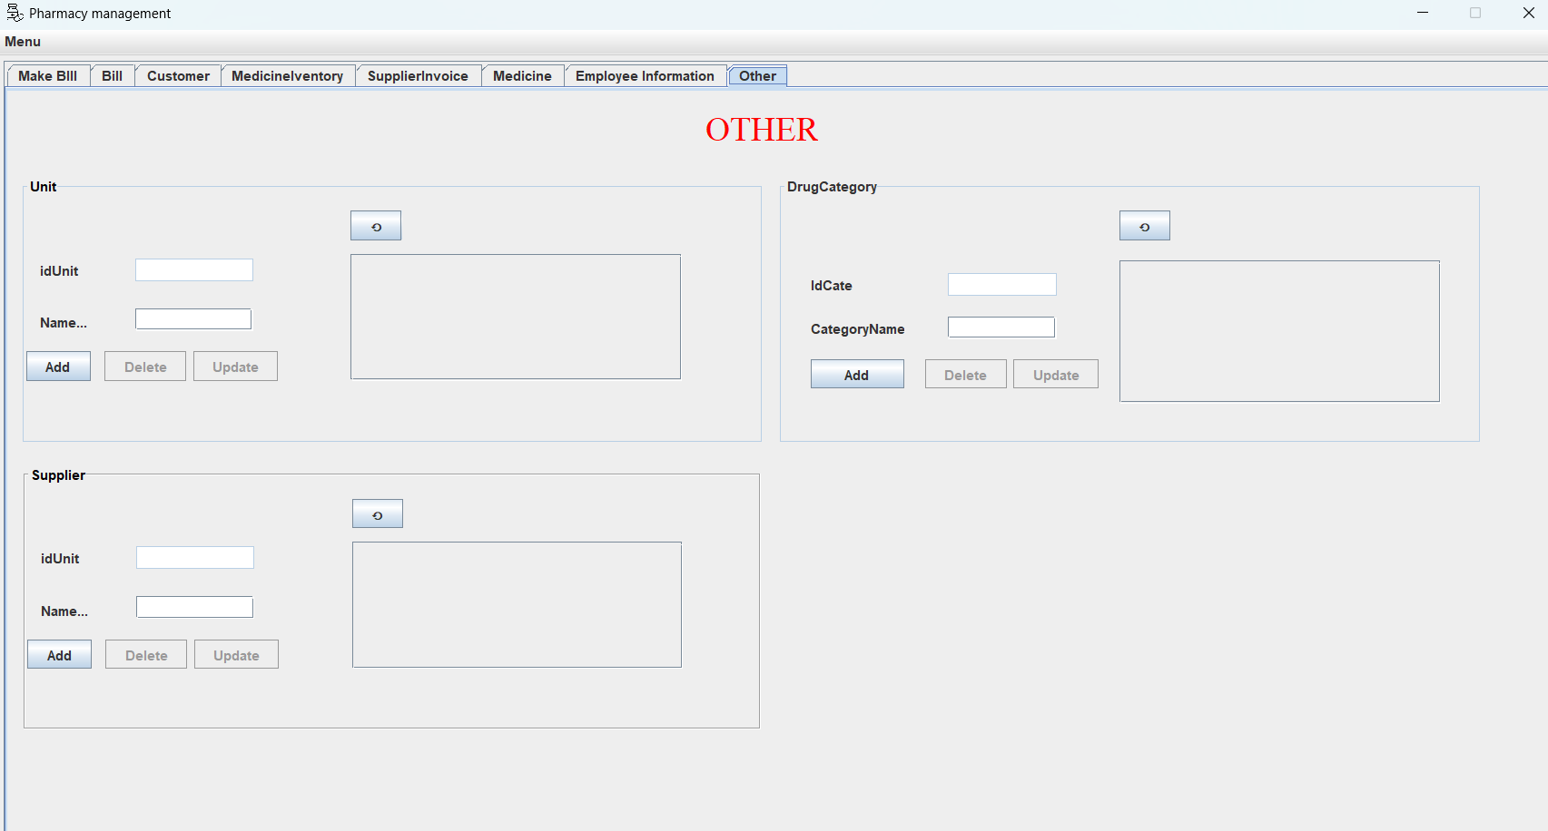
VII. Conclusion:
The Pharmacy Management System project holds great potential for enhancing the efficiency and effectiveness of drug store operations. By automating various aspects of pharmacy management, it will enable better service to customers and streamlined processes for pharmacy staff. As the project progresses, we anticipate significant benefits for the pharmacy and its customers.

